Phase 5 – Deployment, Documentation and Final Presentation
Document Technical Blueprint

Phase Overview
This document provides a detailed technical blueprint of the metro ticket booking system implemented on the ServiceNow platform. It explains the system’s technical architecture, automation logic, data flow, and configuration elements used to achieve end-to-end ticket booking and QR-based validation.

1) Purpose
The purpose of this document is to present the technical foundation of the application, enabling administrators, developers, and evaluators to understand how the system is built, configured, and maintained. It serves as a reference for future enhancements and system handover.

2) QR Code Generation Logic
A) QR Generation Script Overview
QR code generation is implemented using a Catalog Client Script (OnSubmit). The script captures the unique request identifier and constructs a ticket URL, which is then encoded into a QR code and displayed in a modal window.
This approach ensures each ticket is uniquely identifiable and securely linked to backend records.

B) QR Code Script Snippet (Reference)
The client script uses ServiceNow APIs such as g_form.getUniqueValue() and GlideModal to render the QR code dynamically. This logic avoids server-side dependencies and provides immediate feedback to the user after submission.
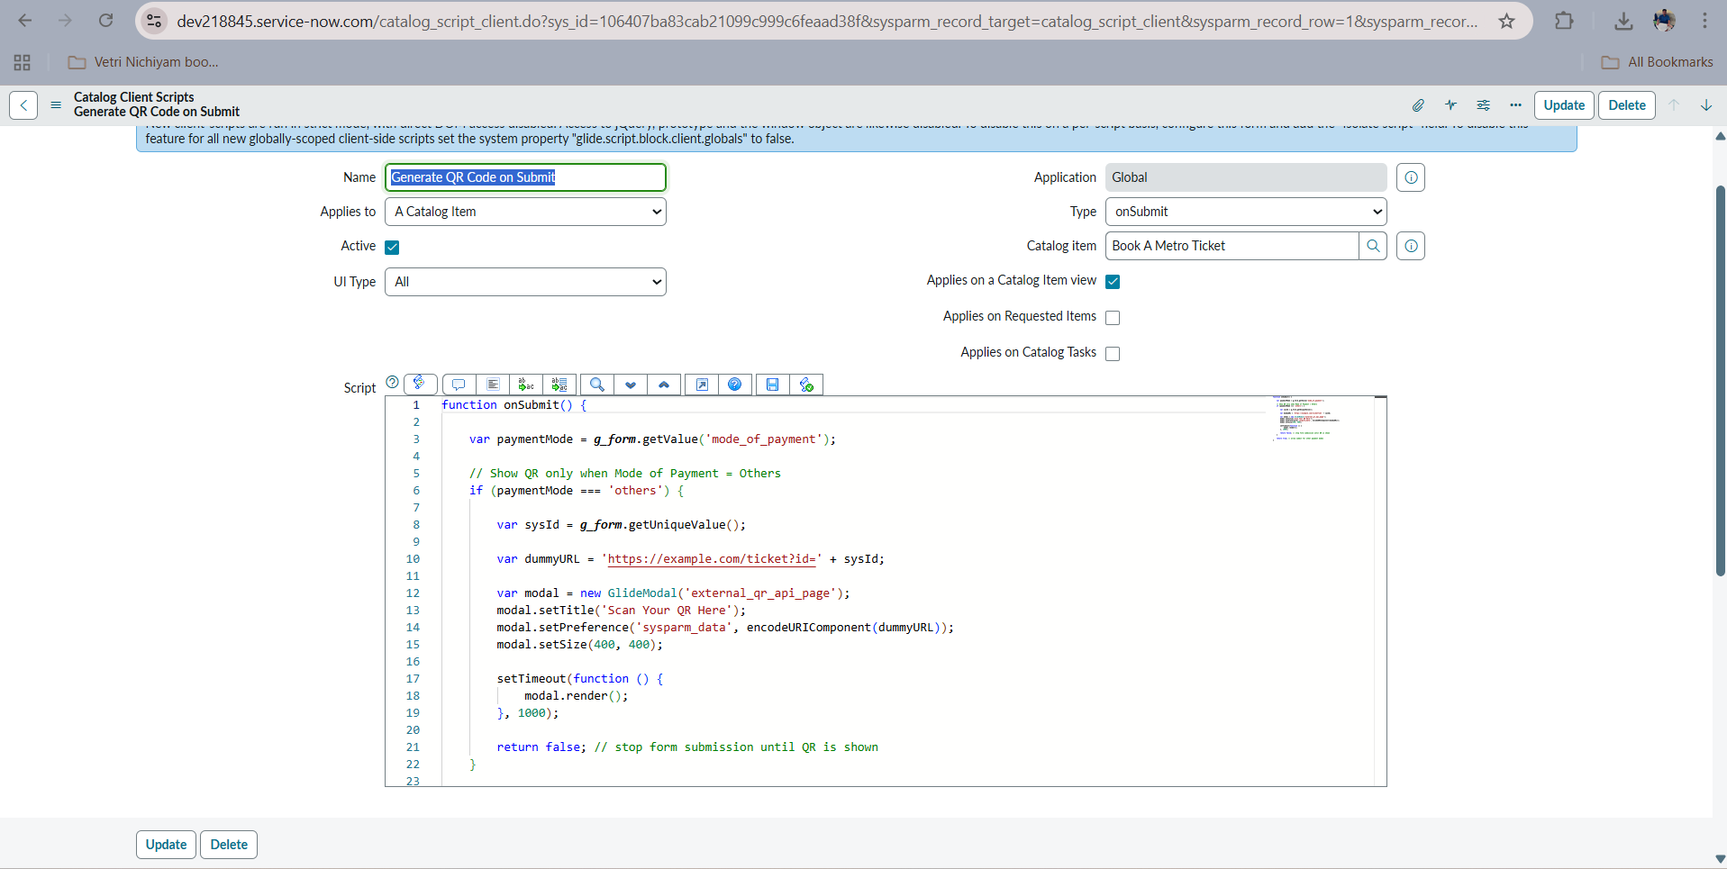
3) Flow Designer Architecture
A) Flow Designer Workflow Overview
Flow Designer is used as the core automation engine to handle backend processes without relying on custom business rules. The workflow is triggered by Service Catalog submissions and orchestrates variable retrieval, record creation, and data persistence.

B) Key Logic Paths
Key logic paths in the flow include:
- Trigger execution on catalog item submission
- Retrieval of catalog variables using the Get Catalog Variables action
- Conditional processing based on journey type or payment mode
- Creation of records in the Metro_Database table
Each action executes sequentially, ensuring reliable data handling.
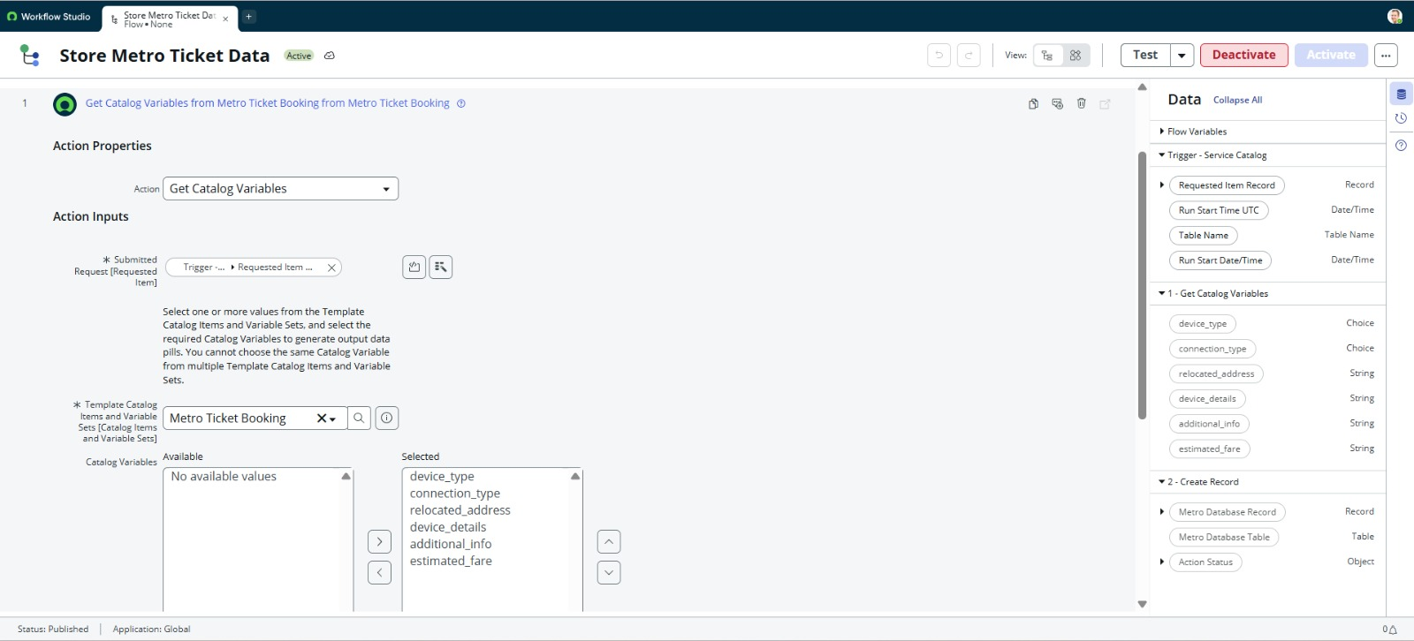

C) Flow Execution Explanation
Flow execution logs were used to verify successful action completion and condition evaluation. This ensures transparency and ease of debugging during development and deployment.
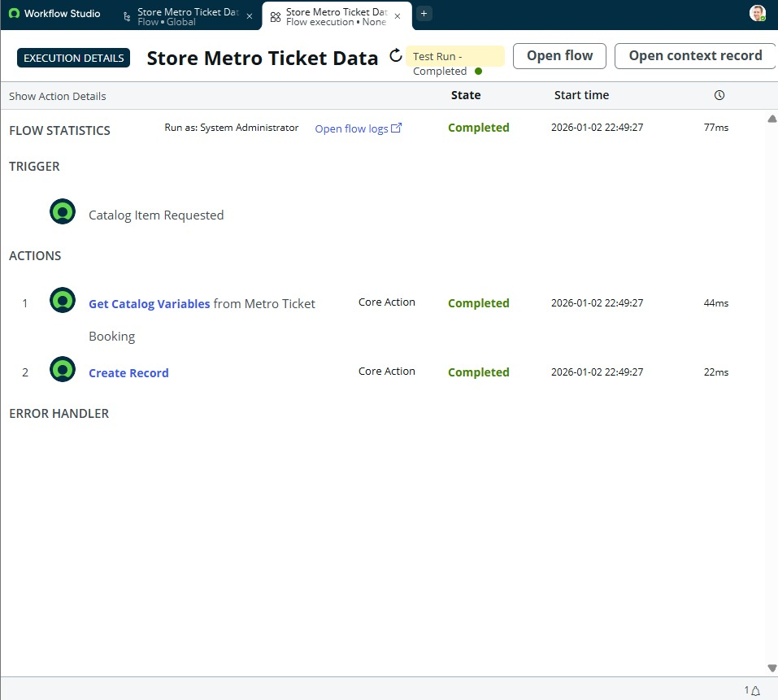

4) Variable-to-Field Mapping Logic
A) Catalog Variables Mapping
User inputs captured through catalog variables are mapped directly to corresponding fields in the custom Metro_Database table using Flow Designer’s Create Record action. This eliminates manual mapping and reduces data inconsistency.

B) Mapping Configuration
The mapping logic ensures:
- Accurate transfer of source and destination stations
- Correct fare values based on journey type
- Storage of passenger and booking details
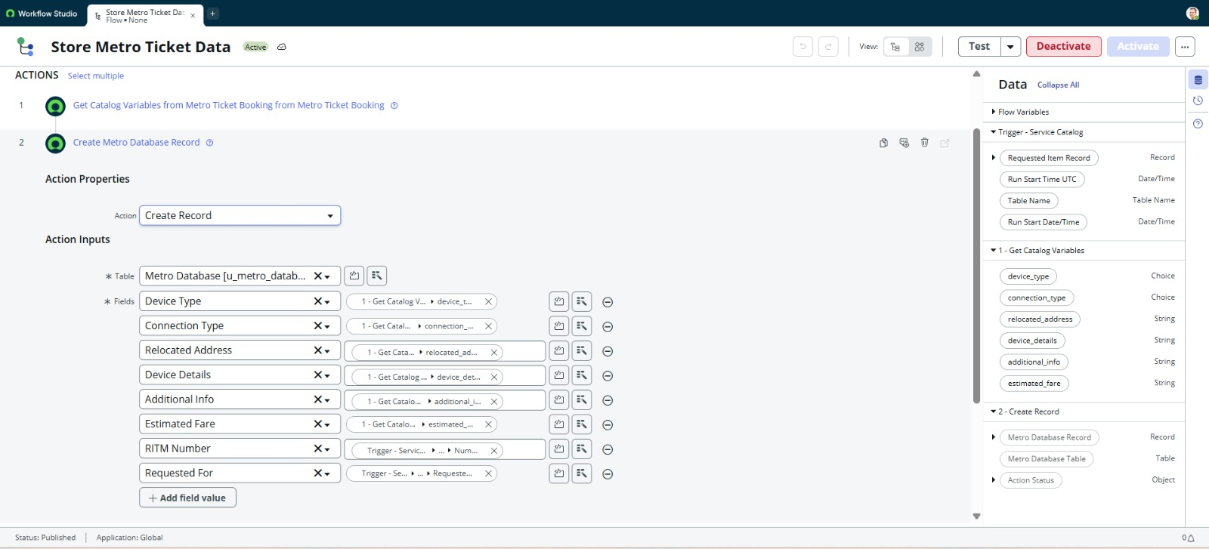
5) Custom Table Schema – Metro_Database
A) Table Structure
A custom table named Metro_Database was created to store ticket and journey details. The table includes fields such as station details, passenger information, fare amount, journey type, and system metadata.

B) Schema Design
Field types were carefully chosen (String, Choice, Reference, Integer, Date) to ensure optimal data storage and performance. Default ACLs were used to maintain secure access.
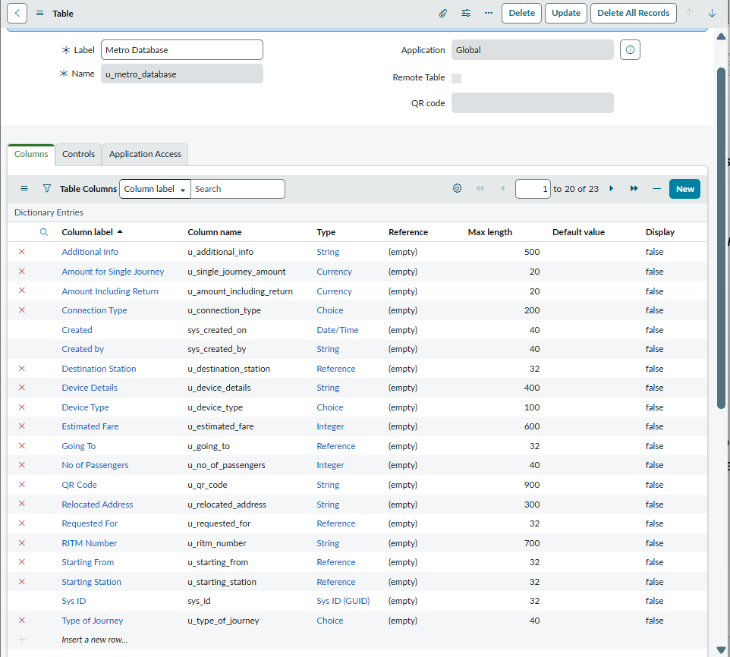

6) Portal Configuration
A) Service Portal Catalog Setup
The Book A Metro Ticket catalog item was added to the Service Portal under the appropriate catalog and category to ensure easy discoverability for users.

B) Category and Catalog Mapping
Catalog and category configurations were validated to ensure correct visibility and access for end users through the Service Portal.

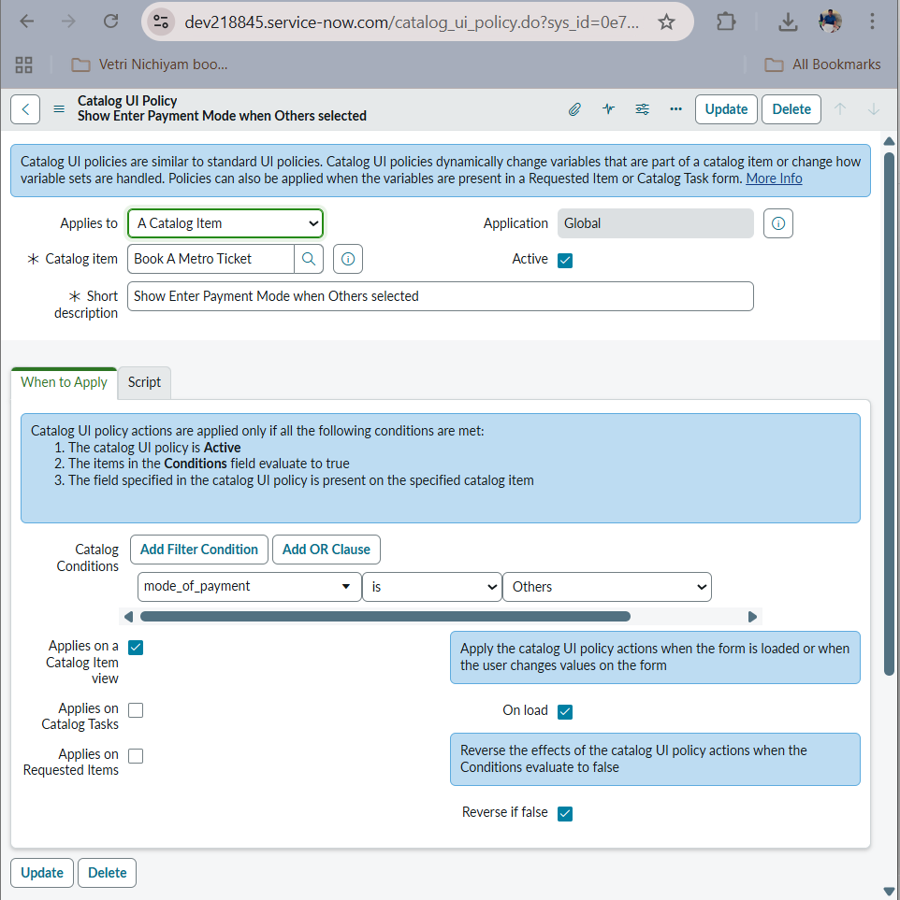

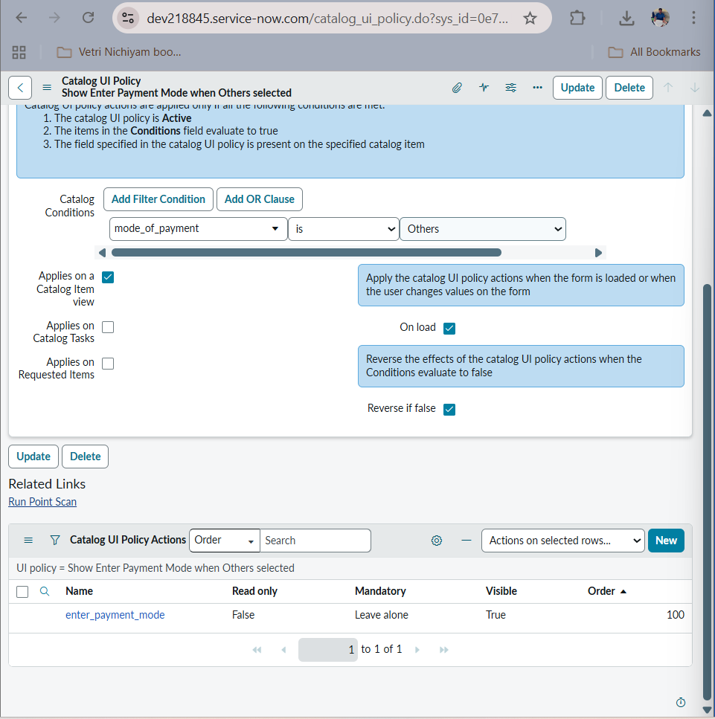

7) Outcome
The technical blueprint confirms that the system is built using scalable, low-code ServiceNow features such as Flow Designer, Service Catalog, and UI policies. The architecture supports automation, maintainability, and future extensibility with minimal dependency on custom scripts.

